**Assignment 3 Answers**

Question 1A

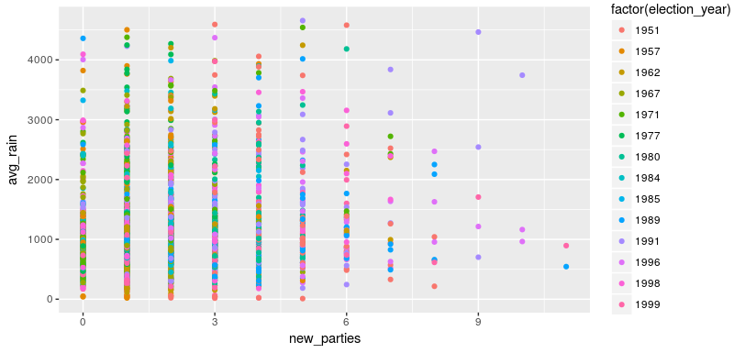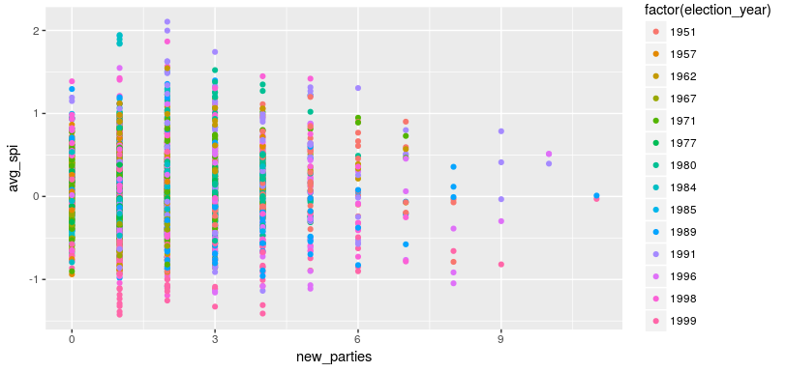

Question 1B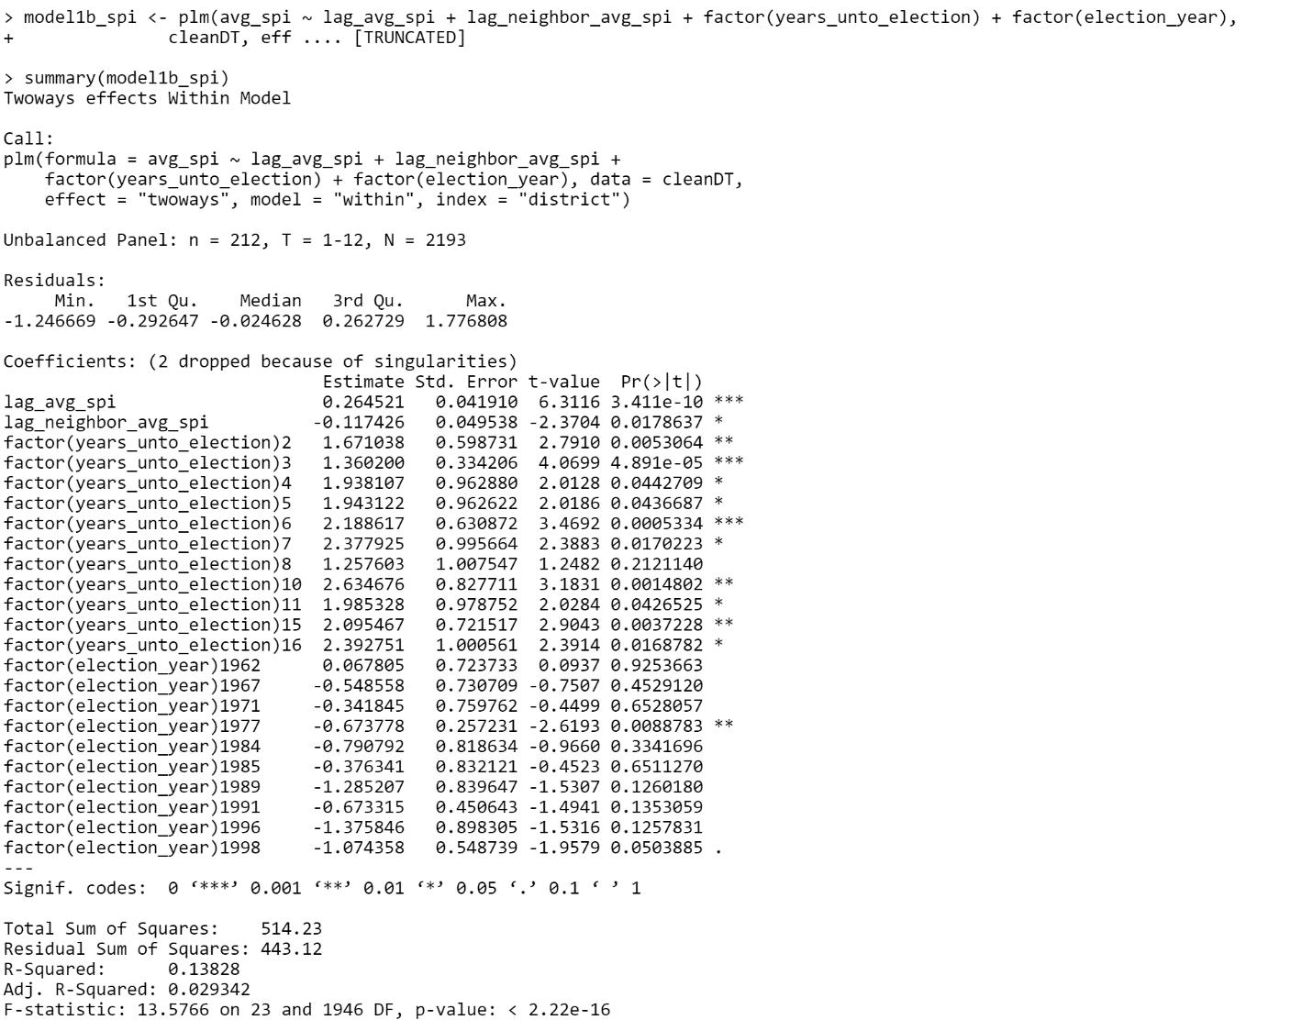

Question 1C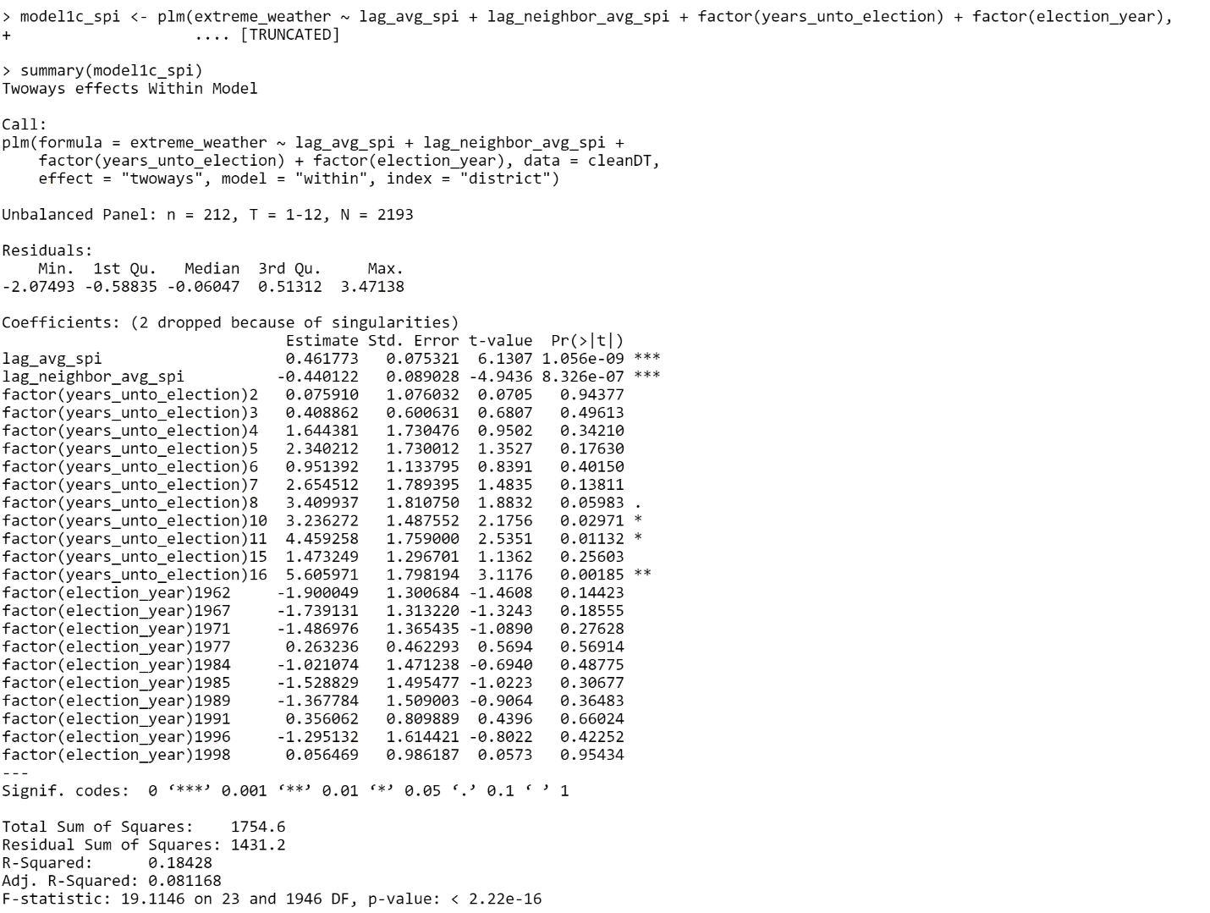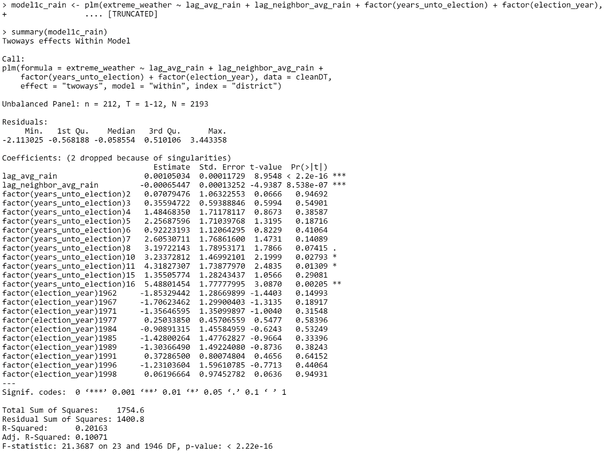

Question 2 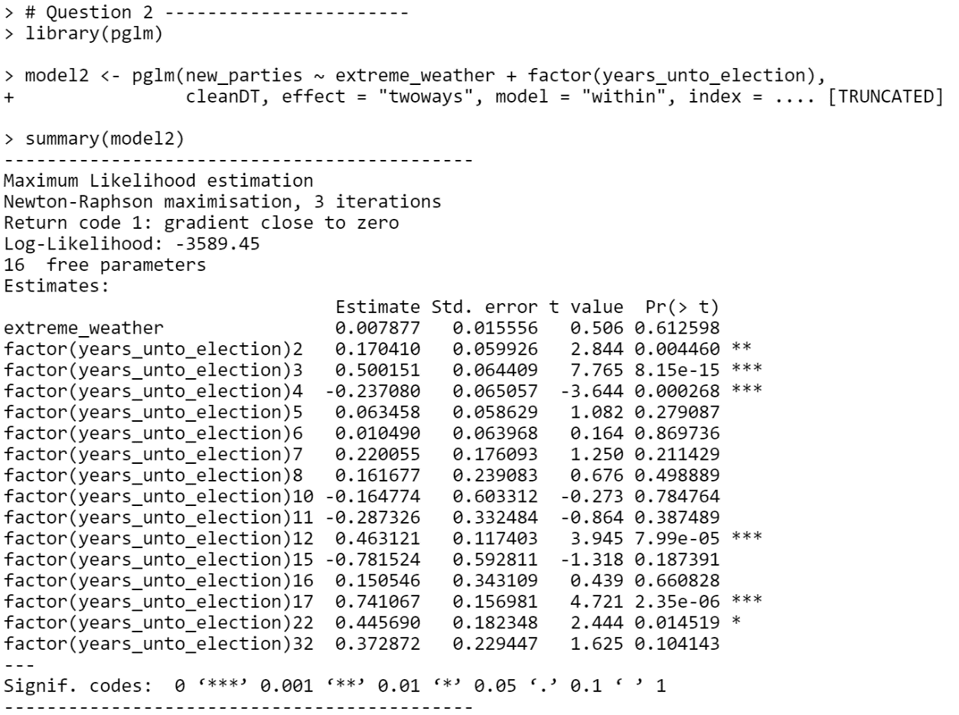

Question 3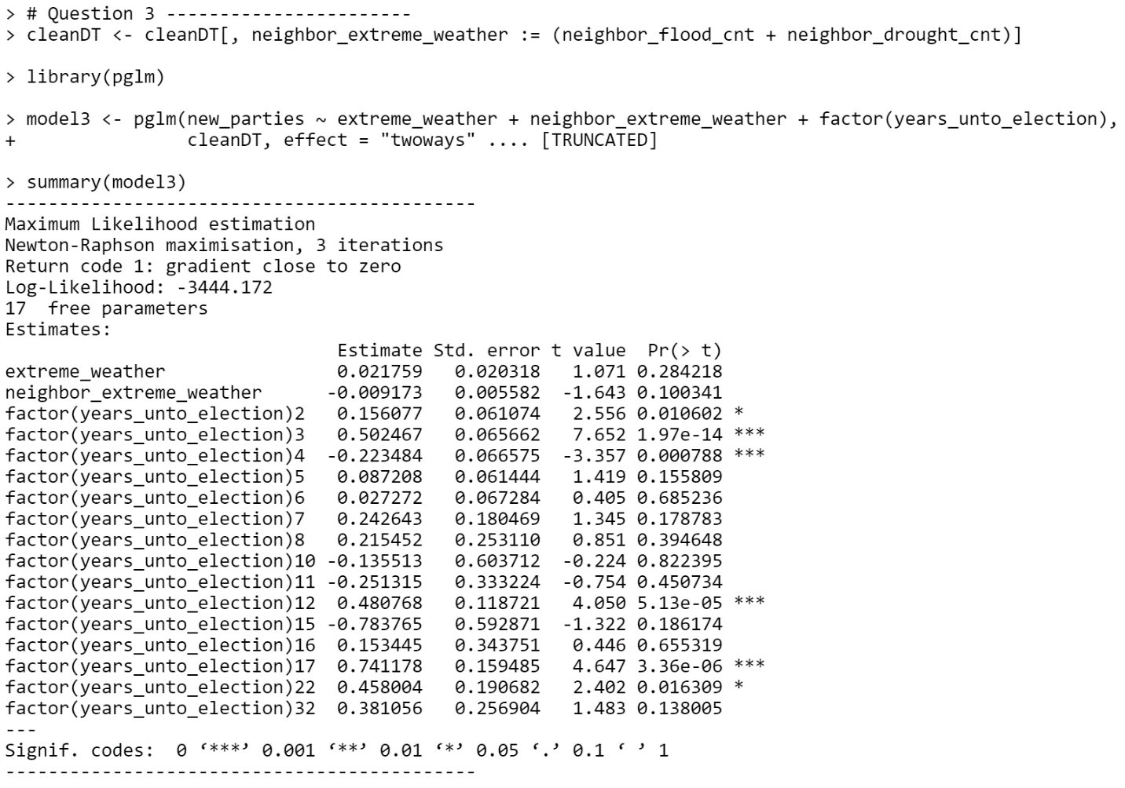

Question 4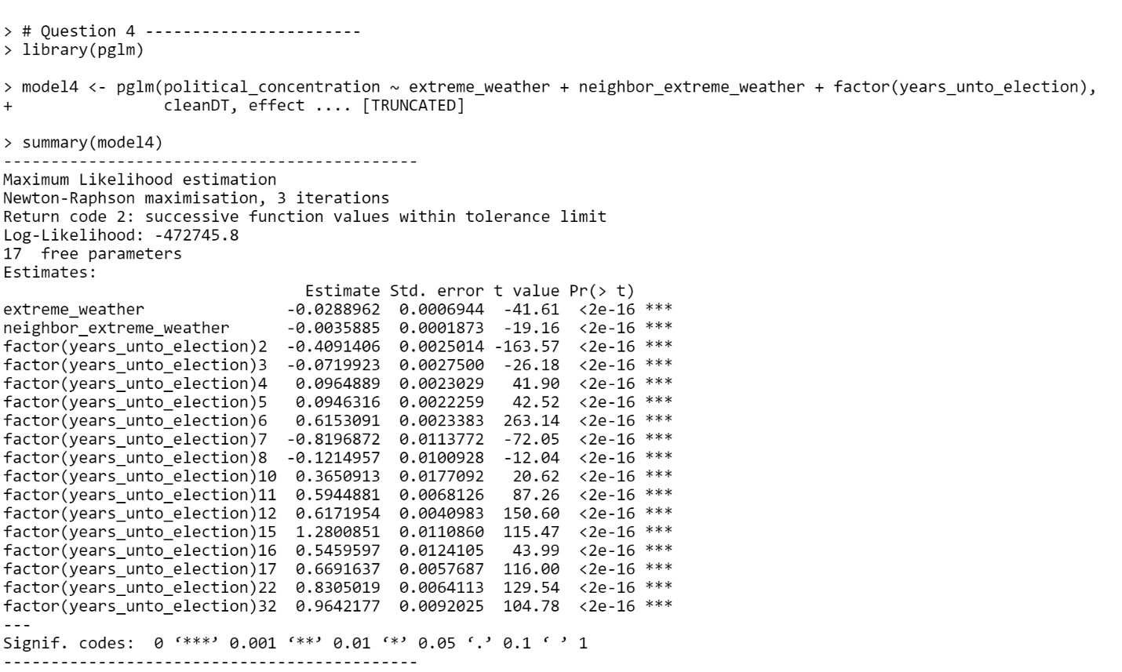

Question 5

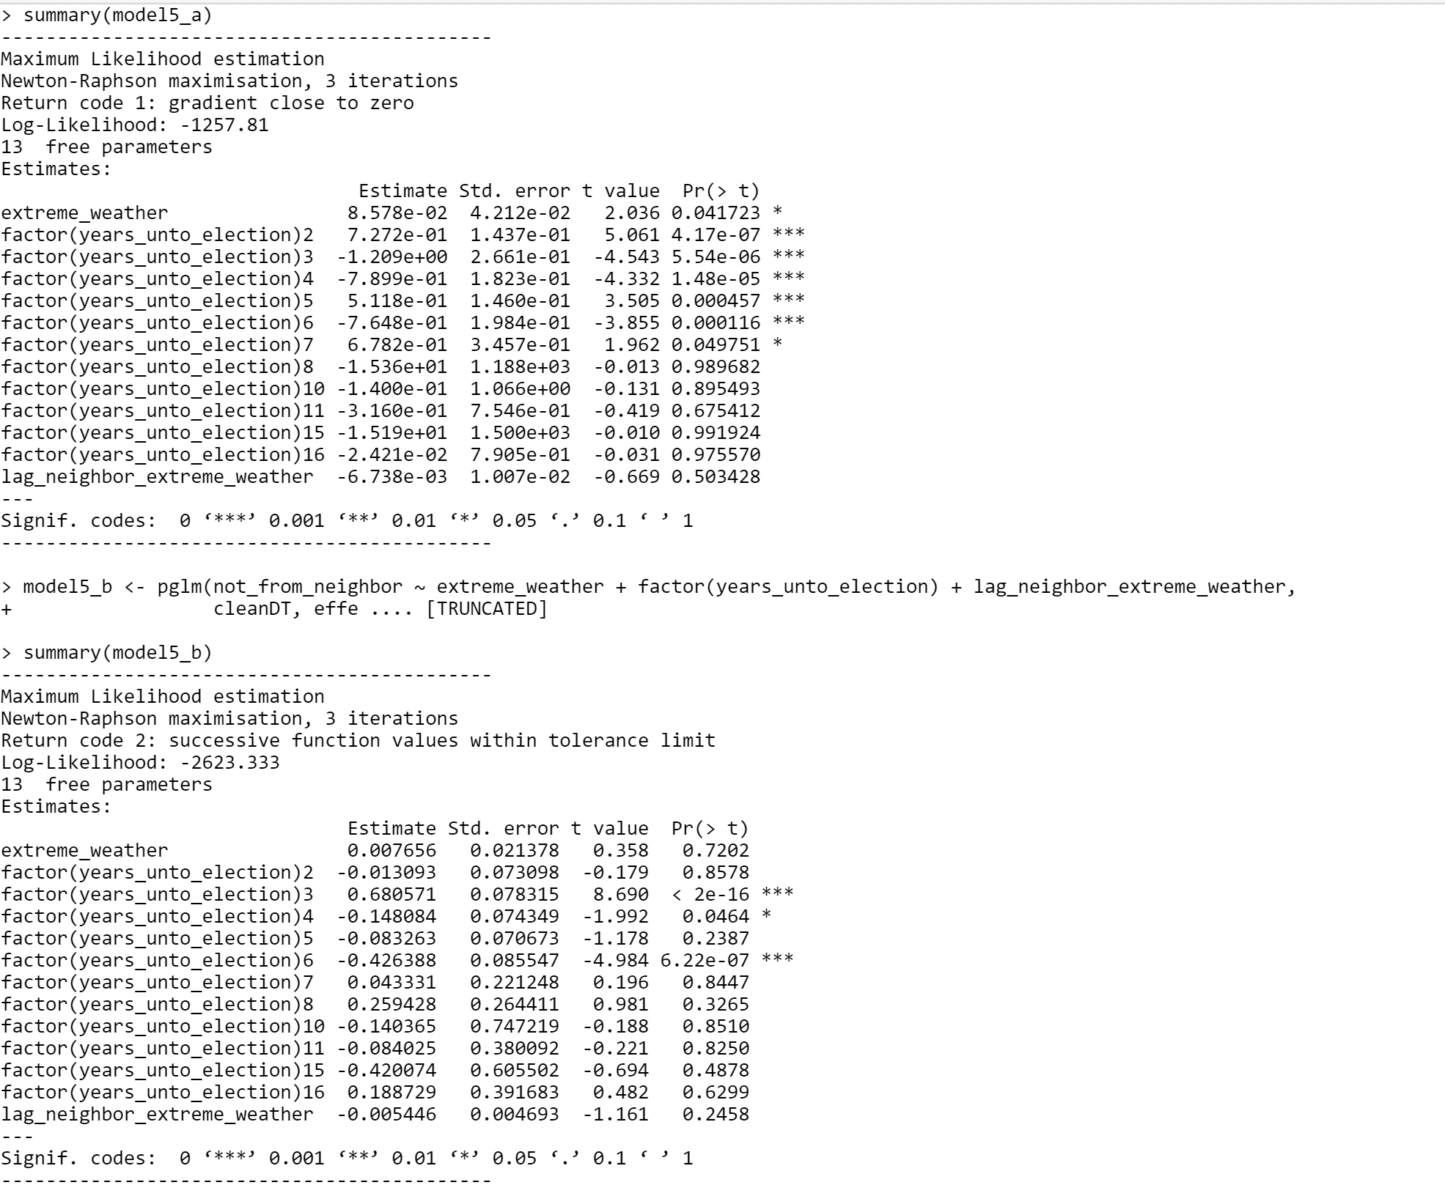

Note : The code submitted runs without any errors. Env variables are cleaned to keep only the useful ones in the environment. 1st line of the code, change the directory to downloaded dir and place the datasets in the directory same as the R file. Approx. running time on 16GB machine ~2 Mins.